title

For who, what project

**REVISION STATUS SHEET**

|  |  |  |  |  |
| --- | --- | --- | --- | --- |
| Revision Number | Effective Date | Description / Summary of Revision | Copy updated by  Initials Date | |
| 00 | 07-Jul-2023 | Initial version | Gabriel Chen | 07-Jul-2023 |
|  |  |  |  |  |
|  |  |  |  |  |
|  |  |  |  |  |
|  |  |  |  |  |
|  |  |  |  |  |
|  |  |  |  |  |
|  |  |  |  |  |
|  |  |  |  |  |
|  |  |  |  |  |
|  |  |  |  |  |
|  |  |  |  |  |
|  |  |  |  |  |
|  |  |  |  |  |

Contents

1. Introduction 4

1.1. Objective 4

1.2. Scope of work 4

2. Terminology 5

2.1. OG Box 5

2.2. Control cabinet 5

3. Installation and electrical wiring 8

3.1. Control cabinet to be installed within or close to the OG Box 8

3.2. Making Cable entry between OG Box and control cabinet 8

3.3. Three phase power connection from OG Box to control cabinet 8

3.4. Leakage coil to be installed in OG Box 9

3.5. Leakage coil wiring to Segment Controller 9

3.6. 3-phase coil to be installed in OG Box 10

3.7. 3-phase coil wiring to Segment Controller 11

3.8. 3 x meter CT (Current Transformer) to be installed in the cabinet 11

3.9. 3 x meter CT wiring to meter (Socomec Diris A10) 12

3.10. RC snubber to be installed cross main contactor A1 and A2 terminal 13

3.11. Contactor control cable change over 13

3.12. Door switch to be installed at OG Box 13

4. Energise test 16

4.1. Pre-check 16

4.2. Power up the OG Box as well as control cabinet 16

4.3. Getting Segment Controller online 16

5. Commissioning 17

5.1. Connected Component discovery 17

5.2. IO Configuration 17

5.3. Calendar setting 18

6. Functional test 20

6.1. Manual bypass 20

6.2. ON/OFF testing 20

6.3. Mains failure alarm testing 20

6.4. Cabinet door open alarm testing 20

7. Sign off 22

8. Summary 23

# EXECUTIVE SUMMARY

## PROJECT BACKGROUND

(Why this project starts, who are the parties involved)

## OBJECTIVE

* + 1. (List the objectives of this project);

## APPROACH

* + 1. (roughly summary what will be done, no need to specify who does what);

# TERMINOLOGY (IF ANY)

## MOU : Memorandum of Understanding

A memorandum of understanding, or MOU, is a nonbinding agreement that states each party's intentions to take action, conduct a business transaction, or form a new partnership. This type of agreement may also be referred to as a letter of intent (LOI) or memorandum of agreement (MOA).

## PV : Photovoltaics, or Photovoltaics Panel

Photovoltaics is the conversion of light into electricity using semiconducting materials that exhibit the photovoltaic effect, a phenomenon studied in physics, photochemistry, and electrochemistry. The photovoltaic effect is commercially used for electricity generation and as photosensors.

Photovoltaics Panel, aka Solar Panel, is a device that converts sunlight into electricity by using photovoltaic cells. PV cells are made of materials that generate electrons when exposed to light. The electrons flow through a circuit and produce direct current electricity, which can be used to power various devices or stored in batteries.

# ABOUT OUR COMPANIES

## ABOUT LITEON

(LITEON Introduction)

## COMPANY DOMAIN EXPERIENCE

(Introduction of LITEON’s experience in related domain)

## ABOUT SUBSIDIARY COMPANY

(Introduction of LITEON Singapore)

# ABOUT THE SYSTEM BEEN PROPOSED

## GENERAL MARKET NEEDS, AND/OR CUSTOMER PAIN POINT

(General market trends and needs, and/or this specific customer’s pain point)

## PROPOSED SYSTEM BENEFITS (IN ADDRESSING THE MARKET NEEDS)

(What are the system features to address the said general market needs)

## SYSTEM ARCHITECTURE

(Insert System Architecture)

## Three phase power connection from OG Box to control cabinet

* + 1. Power off the target OG Box via open the main incoming MCB;
    2. Disconnect the 3 phase + Neutral cable from the contactor incoming terminals
       1. Neutral connection can be tapped from target feeder pillar neutral bar if required;
    3. Connect the additional 4 core 1.5mm2 (or better) cable and extend it to control cabinet designated power connection terminals;

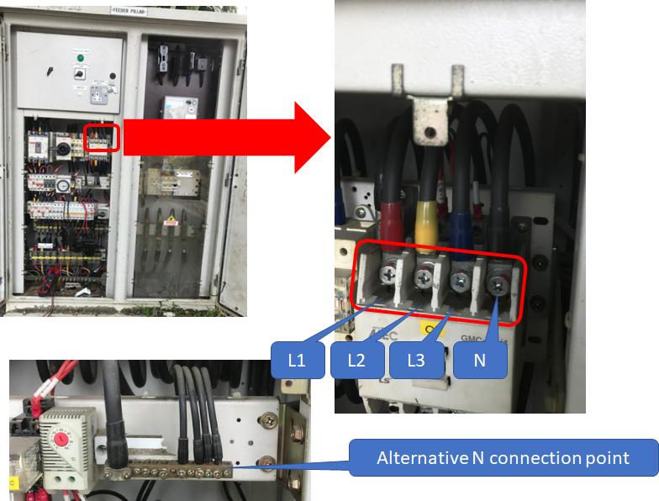

## Leakage coil to be installed in OG Box

* + 1. Upon disconnecting the 3 phase + N cable from contactor, leakage coil should be installed in the way that to include all 4 (four) cables for earth leakage current detection;

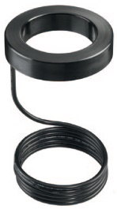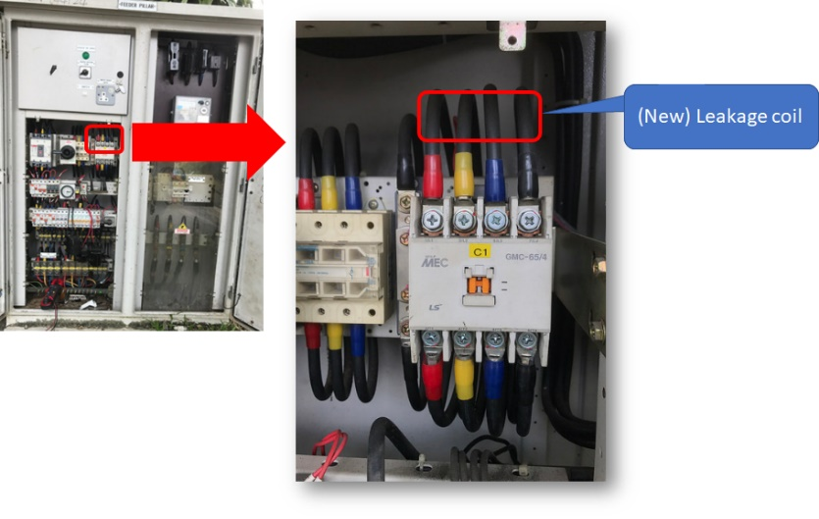

## Leakage coil wiring to Segment Controller

* + 1. Leakage coil cable back to control cabinet should goes thru the target OG Box cable entry, protected by the cable conduit and finally goes into the control cabinet;
    2. Leakage coil cable should be connected to the Segment Controller directly to ensure the measurement accuracy and wiring follow the wiring diagram below:

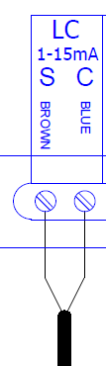

## 3-phase coil to be installed in OG Box

* + 1. Several units of 3-phase coil to be installed in every individual outgoing segment to achieve individual segment current monitoring;
    2. The installer should survey OG Box to define the installation position of the 3-phase coil to ensure that the circuits to be monitored go through at least one hole of the 3-phase coil;
    3. The installer should survey the OG Box to define the number of the 3-phase coil to be installed to ensure that all of the circuits to be monitored are included;
       1. The current goes through each hole of the 3-phase coil should not be less than 0.5 A. The installer is suggested to implement multiple loops or grouping the circuits to fulfil this requirement;
       2. Up to 60 circuits can be monitored. In the event of exceeding the limitation, the installer should seek customer approval to group some circuits from the same phase;
    4. The outgoing 3-phase cables should be disconnected from the original terminal after shutting down main incoming power for installation;
    5. The 3-phase coils are to be installed and connected according to the provided wiring diagram;
    6. Each individual outgoing cable must go thru the one hole on the 3-phase coil respectively;
    7. It is recommended that to install the 3-phase coil in the way that the phase of the circuit matches the installation instruction so that the alarm description matches the onsite installation;
    8. Resume original connection for the disconnected cables;

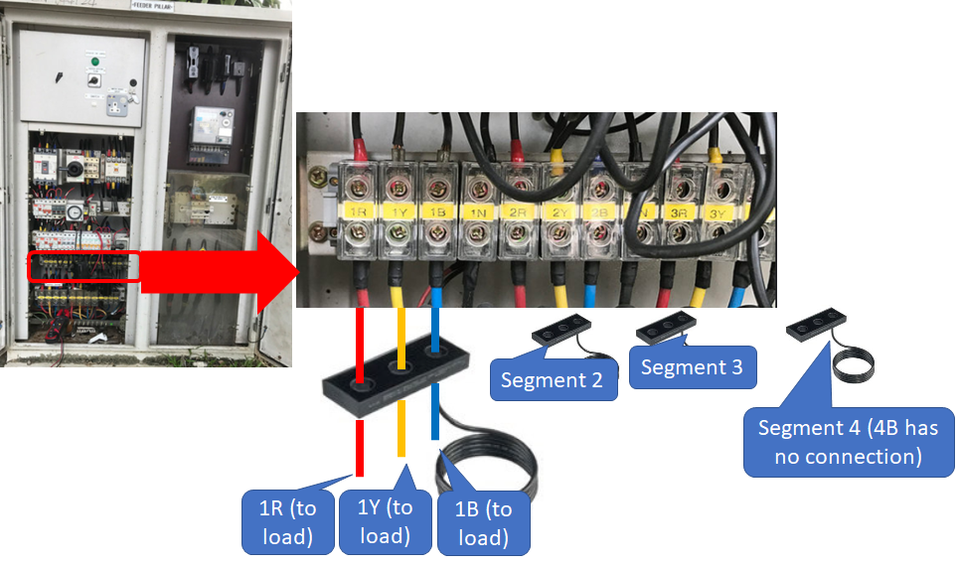

## 3-phase coil wiring to Segment Controller

* + 1. 3-phase coil cable back to control cabinet should goes through the target OG Box cable entry, protected by the cable conduit and finally goes into the control cabinet;
    2. 3-phase coil cable should be connected to the Segment Controller directly to ensure the measurement accuracy and wiring follow the wiring diagram below:

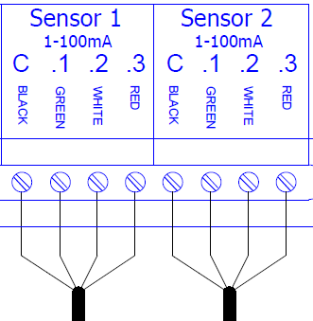

## 3 x meter CT (Current Transformer) to be installed in the cabinet

* + 1. The installer should survey the OG Box to define the specification of the meter CT rating. Such as 100/5A, or 150A/5A;
    2. Upon disconnecting the 3 phase + N cable from contactor, 3 units of meter CTs should be installed to L1, L2 and L3 respectively according to the provided integration plan;
    3. CT installation should be installed in the way that Primary current flows in from the “K-P1” and flows out from “L-P2” and thereafter to the loads;
    4. 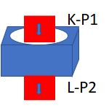

## 3 x meter CT wiring to meter (Socomec Diris A10)

* + 1. 3 units of meter CTs cable (6 cables, 1.5mm2 or better) back to control cabinet should goes through the target OG Box cable entry, protected by the cable conduit and finally goes into the control cabinet;
    2. CTs secondary connection (S1 & S2) should follow the provided wiring diagram:
    3. 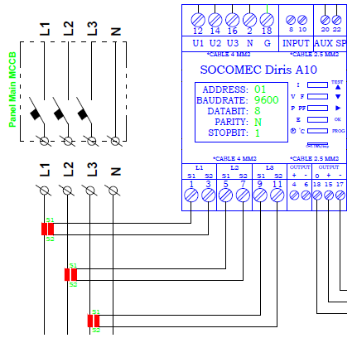

## RC snubber to be installed cross main contactor A1 and A2 terminal

* + 1. The installer should survey the OG Box to define the number of the contactor in the OG Box, so that to define :
       1. The number of relays needed;
       2. The installation method (selection between “Up to 2 contactors” or “more than 2 contactors”);
       3. The number of RC snubber needed (one RC snubber per contactor);
    2. RS snubber shall be installed cross the contactor A1 and A2 terminal according to the provided integration plan;

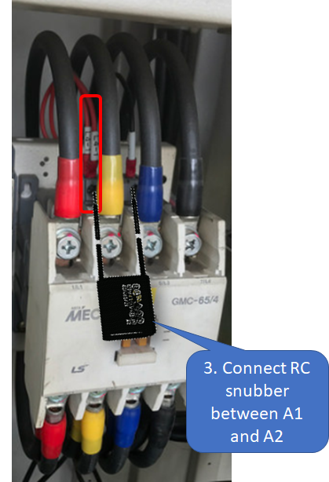

## Contactor control cable change over

* + 1. The installer should inspect and discuss with PUB to determine the control mechanism and wiring revision;
    2. Generally speaking, there are 2 existing contactor control cables: one is from the timer and another is from the bypass switch;
    3. AmpLight cabinet is taking over control from the timer, hence the connection to contactor control coil must be made according to the provided wiring diagram;

## Door switch(es) to be installed

* + 1. The installer should survey the OG Box to define the quantity of the door switch to be installed as well as the installation method;
    2. The installer should install the door switch in the way that when the target OG Box door is opened, it resumes the natural position so that the internal circuit is closed
    3. The door switch 02 should be connected parallel to the pre-assembled door switch 01 according to the provided wiring diagram;
    4. Connection terminal 31 and 32 (Normal Closed) should be connected between Component “Surge Guard” and Component “Segment Controller”;
    5. Terminal 31 on both door switches should connects to “Bell” terminal on Surge Guard;
    6. Terminal 32 on both door switches should connects to “Bell” terminal on Segment Controller;

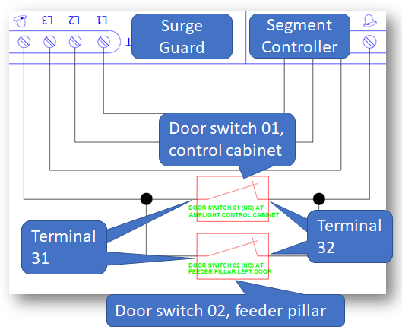

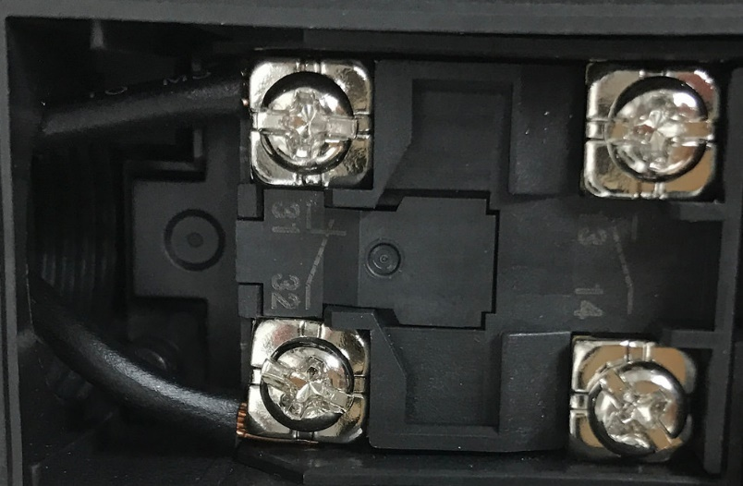

# Energise test

# 

## Pre-check

* + 1. Control cabinet installation is done properly;
    2. OG Box main MCB is opened (i.e. OG Box and control cabinet are not energised);
    3. No flying bare cable in the target OG Box and Control cabinet;
    4. 3-phase + N connection from target OG Box to control cabinet is correct;
    5. Leakage coil installation and connection is correct;
    6. 3-phase coil installation and connection is correct;
    7. 3 units of meter CTs installation and connection is correct;
    8. RS-snubber(s) had been installed;
    9. Control cable from control cabinet is to contactor directly or via selector switch correctly according to the provided wiring diagram;
    10. Original timer cable was sealed properly or been connected to selector switch properly;
    11. Door switch(es) installation and connection are done properly;

## Power up the OG Box as well as control cabinet

* + 1. OG Box should be energised and without tripping etc., existing component LED or other components display should be turned on and observable;
    2. Control cabinet should be energised and without tripping etc., Segment Controller LED or other components display should be turned on and observable;

## Getting Segment Controller online

* + 1. With the correct installation and connection, the Segment Controller should get itself online in the AmpLight UI;

# Commissioning

# 

## Connected Component discovery

* + 1. Access “asia.amplight.philips.com” > Singapore_PUB > {Name of the OG Box} > [Box] > [Status];
    2. The connected modules should be discovered:
       1. 1 x DALI interface;
       2. And another installed components (subject to the installation on site);

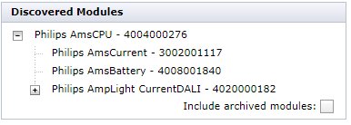

## IO Configuration

* + 1. Access [Box] > [IO configuration];
    2. Voltage threshold = 253 V ~ 207 V;

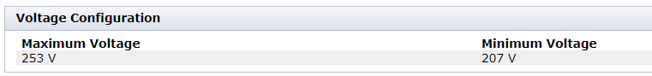

* + 1. Relay configuration: all relays should be configured on {Name of the OG Box};

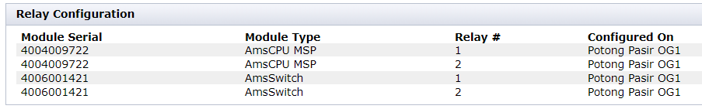

* + 1. Leakage sensor configuration: Segment Controller Leakage sensor interface should be configured on {Name of the OG Box};
    2. 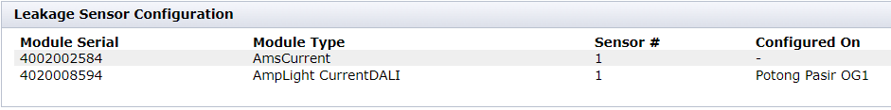
    3. Current sensor configuration:
       1. The quantity of the segment and outgoing circuit subject to the OG Box condition;
       2. Current sensors should be configured on {Name of the OG Box}, each individual segment respectively;
       3. Different current sensors threshold setting should be done onsite according to the real full-load reading from the system;

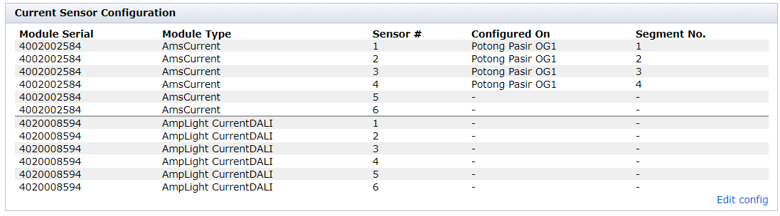

## Calibration

* + 1. Access “https://asia.amplight.philips.com/” > Singapore_PUB > Potong Pasir OG1 > [Box] > [Light];
    2. The lamp failure threshold setting (power-drop) should be configurated to provide Waring at 10 % and Critical fault at 30%:

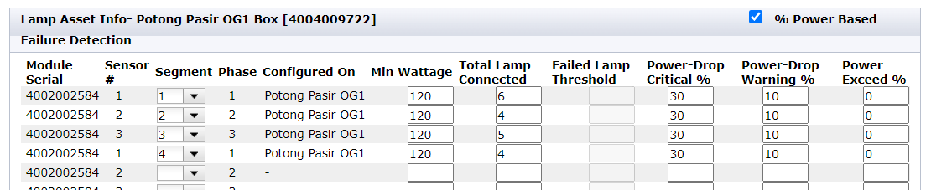

## Calendar setting

* + 1. According to the convention the switching time for timer is 7:00PM(ON)-7:00AM(OFF);
    2. Access “asia.amplight.philips.com” > {Name of the OG Box} > [Program];
       1. The OG Box should have inherited program “PUB_19-7” from upper node “PUB_Singapore” which defines 7:00PM(ON)-7:00AM(OFF):

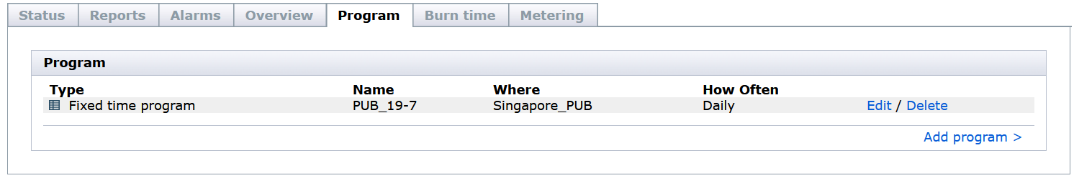

* + - 1. Schedule details : 7:00PM(ON)-7:00AM(OFF):

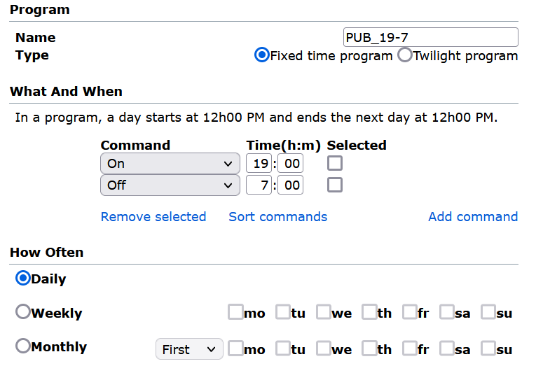

# Functional test

# 

## Resuming timer control

* + 1. Turn the selector switch in control cabinet from “AmpLight” (or AUTO or other naming) position to “Timer”;
    2. The contactors be controlled by timer;
       1. Result: ___________________
    3. Turn the selector switch in control cabinet from “Timer” position to “AmpLight”;
    4. The contactors be controlled by AmpLight system;
       1. Result: ___________________

## ON/OFF testing

* + 1. Access “asia.amplight.philips.com” > {Name of the OG Box} > execute manual command to ON or OFF the OG Box;
    2. Execute command [ON], and the luminaire should be turned on;
       1. Result: ___________________
    3. Execute command [OFF], and the luminaire should be turned off;
       1. Result: ___________________

## Lamp failure detection

* + 1. Confirm the lights of this OG Box is turned ON by AmpLight Segment Controller;
    2. Shut down one or multiple luminaires (at least 30%) of a channel (easy way is turn off the MCB of a circuit);
    3. Access “asia.amplight.philips.com” > {Name of the OG Box} > Box UI should indicate the Lamp failure fault been triggered around 15 to 20 minutes, and the notification should be sent to the configured recipient;
       1. Result: ___________________
    4. Resume the original condition and the triggered fault should be cleared from UI;
       1. Result: ___________________

## Mains failure alarm testing

* + 1. Manually switch off the mains power supply to control cabinet via open all (3 units) incoming MCBs;
    2. Access “asia.amplight.philips.com” > {Name of the OG Box}, a “Mains failure” alarm should be reported;
       1. Result: ___________________
    3. Manually switch on the mains power supply to control cabinet via closed all (3 units) incoming MCBs;
    4. Access “asia.amplight.philips.com” > {Name of the OG Box}, the reported “Mains failure” alarm should be cleared;
       1. Result: ___________________

## Cabinet door open alarm testing

* + 1. Open control cabinet door;
    2. 6.2.1. Access “asia.amplight.philips.com” > {Name of the OG Box}, a “cabinet door open” alarm should be reported;
       1. Result: ___________________
    3. Close control cabinet door;
    4. Access “asia.amplight.philips.com” > {Name of the OG Box}, the reported “cabinet door open” alarm should be cleared;
       1. Result: ___________________
    5. Open target OG Box door;
    6. Access “asia.amplight.philips.com” > {Name of the OG Box}, a “cabinet door open” alarm should be reported;
       1. Result: ___________________
    7. Close target feeder pillar left compartment door;
    8. Access “asia.amplight.philips.com” > {Name of the OG Box}, the reported “cabinet door open” alarm should be cleared;
       1. Result: ___________________

# Sign off

|  |  |  |  |  |  |  |  |  |  |  |  |  |  |
| --- | --- | --- | --- | --- | --- | --- | --- | --- | --- | --- | --- | --- | --- |
|  |  |  |  |  |  |  |  |  |  |  |  |  |  |
|  |  |  |  |  |  |  |  |  |  |  |  |  |  |
|  | INSTALLED BY: |  |  |  |  |  |  | INSTALLED BY: |  |  |  |  |  |
|  |  |  |  |  |  |  |  |  |  |  |  |  |  |
|  | N&T ENGINEERING ENTERPRISE PTE LTD | |  |  |  |  |  | SIGNIFY SINGAPORE PTE LTD | | |  |  |  |
|  |  |  |  |  |  |  |  |  |  |  |  |  |  |
|  | NAME: |  |  |  |  |  |  | NAME: |  |  |  |  |  |
|  |  |  |  |  |  |  |  |  |  |  |  |  |  |
|  | SIGNATURE: |  |  |  |  |  |  | SIGNATURE: |  |  |  |  |  |
|  |  |  |  |  |  |  |  |  |  |  |  |  |  |
|  | DATE: |  |  |  |  |  |  | DATE: |  |  |  |  |  |
|  |  |  |  |  |  |  |  |  |  |  |  |  |  |
|  | TESTED BY: | |  |  |  |  |  | TESTED BY: | |  |  |  |  |
|  |  |  |  |  |  |  |  |  |  |  |  |  |  |
|  | PUBLIC UTILITY BOARD | |  |  |  |  |  | SIGNIFY SINGAPORE PTE LTD | | |  |  |  |
|  | M&E REPRESENTATIVE | |  |  |  |  |  |  |  |  |  |  |  |
|  |  |  |  |  |  |  |  |  |  |  |  |  |  |
|  | NAME: |  |  |  |  |  |  | NAME: |  |  |  |  |  |
|  |  |  |  |  |  |  |  |  |  |  |  |  |  |
|  | SIGNATURE: |  |  |  |  |  |  | SIGNATURE: |  |  |  |  |  |
|  |  |  |  |  |  |  |  |  |  |  |  |  |  |
|  | DATE: |  |  |  |  |  |  | DATE: |  |  |  |  |  |
|  |  |  |  |  |  |  |  |  |  |  |  |  |  |
|  | WITNESSED BY: | |  |  |  |  |  | WITNESSED BY: | |  |  |  |  |
|  |  |  |  |  |  |  |  |  |  |  |  |  |  |
|  | PUBLIC UTILITY BOARD | | |  |  |  |  | SIGNIFY SINGAPORE PTE LTD | | |  |  |  |
|  | M&E REPRESENTATIVE | |  |  |  |  |  | REPRESENTATIVE | |  |  |  |  |
|  |  |  |  |  |  |  |  |  |  |  |  |  |  |
|  | NAME: |  |  |  |  |  |  | NAME: |  |  |  |  |  |
|  |  |  |  |  |  |  |  |  |  |  |  |  |  |
|  | SIGNATURE: |  |  |  |  |  |  | SIGNATURE: |  |  |  |  |  |
|  |  |  |  |  |  |  |  |  |  |  |  |  |  |
|  | DATE: |  |  |  |  |  |  | DATE: |  |  |  |  |  |
|  |  |  |  |  |  |  |  |  |  |  |  |  |  |

# Summary

*This section to be annotated when the T&C is completed.*